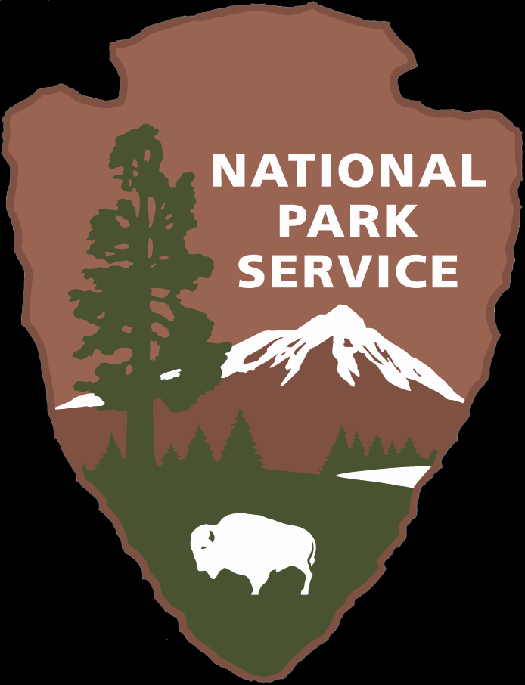

National Park Service
U.S. Department of the Interior

Volunteers-In-Parks Program
Cabrillo National Monument
Lighthouse Kitchen Garden
Cabrillo National Monument

EXPERIENCE YOUR AMERICA™

- Meet people from all around the world
- Great work experience
- Training provided
- Learn about National Park Service careers
- Opportunity to improve your community and your National Park
- Inspire others through your artisitc expression

Knowledge
& Skills

Job Title

Duties
Horticulturalist

For Site Bulletins that are printed front and back, please remove the tagline “Experience Your America” from front page. It should only appear at the bottom of the back page.
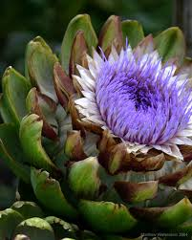
“

Duties
CABR Volunteer Coordinator at Tavo_del_rio@nps.gov or 619-523-4565
- Tend the garden by weeding watering and planting seeds.
- Interact with visitors and invite them in the garden to taste seasonal produce.
- Proper upkeep and maitenance of garden supplies and water hose.
- Knowledge of life at the Lighthouse circa 1887

Contact
- Good communication and interpersonal skills
- Reliable and committed
- Ability and desire to connect with visitors of all ages and cultures
- Enjoys being at peace in the garden
Benefits

The Old Point Loma Lighthouse was not just a housing for the light. It was a home with a garden where children were raised. Produce in the garden was grown to to supplement their supplies which was available from Old Town, which was an all day horse and buggy ride. Vegetables similar to those grown in the latter half of the nineteenth century can be found in the garden today. The Point Loma Garden Club sponsors this cultural aspect of the Lighthouse. Maitenance and upkeep of the garden is always appreciated.
Cabrillo National Monument, Point Loma, San Diego
Times are flexible

Location & Time
Experience your America
EXPERIENCE YOUR AMERICA™

